**<Sentiment Analysis App>**

**Software Development Plan**

**Team Members:**

**Waleed Umar (FA18-BSE-102)**

**Aseed Ali Khokhar (FA18-BSE-015)**

**M.Saqib Khan (FA18-BSE-113)**

Contents

**PROJECT PRODUCTS:** 2

**Interfaces** 3

**Project Development Tools and Methodology** 3

**Standards and Procedures** 3

**Map of Development Process** 4

**Project Staff Organization** 4

**Development Risks and Risk Management Actions** 5

**Milestones** 5

# **PROJECT PRODUCTS:**

|  |  |  |  |
| --- | --- | --- | --- |
| **NO** | **Deliverable** | **Type** | **Date** |
| **1** | Proposal | Hard + Soft Copy | 30th May 2021 |
| **2** | Software Requirement Specification | Hard + Soft Copy | 1st May 2021 |
| **3** | Software Design Document | Hard + Soft Copy | 6th May 2021 |
| **4** | Progress Report | Hard + Soft Copy | Every week |
| **5** | Testing Report | Hard + Soft Copy | After every integration cycle |
| **6** | Prototypes | Soft Copy | 20th July 2021 |
| **7** | Software Product | Cloud + App source code | 5th July 2021 |

# **Interfaces**

The interfaces for our system are as follow:

* The software will interact with the databases to store data
* The software will interact with Twitter API to access its records to perform analysis
* The software will use browser interface to show the data to the user
* The software will interact with Facebook API to export chat and perform analysis

# **Project Development Tools and Methodology**

The software methodology used in this project will be **Agile**. The reason to use this model is to ensure that the project finishes on time. Moreover, this method will help to adapt to changes more quickly and efficiently. Another factor that forced us to select Agile is that the work is divided into small iterations with a limited time that can exist as a separate work product. Since the work is divided into small chunks, the quality of work will be improved as it would be easy to test and validate the system. The quality of the product is an important factor for us as we have to make our product as efficient as possible to generate accurate results.

We will be using an object oriented approach for our project. The rationale behind this decision is to reduce code redundancy as the categories described in modules will be used again and again. So this would help in code reusability. For instance, in order to recommend activities to the user, the system needs to use a sentiment analysis model to analyze the sentiment of the user and then recommend activities accordingly.

The tools used for the developing our project are as follow:

* Tensor flow
* Dart
* Flutter
* Adobe Xd
* Python
* Twitter API
* Facebook Graph API
* Jupyter Notebook
* Instagram API
* MongoDB

The testing methodologies used are as follow:

* Unit Testing
* Integration Testing
* Business Functional Testing
* Browser Compatibility Testing

# **Standards and Procedures**

The project will follow no certain standard nor follow any formal procedures. The developers can work as they see fit. Necessary guidelines to follow will be provided to maintain certain type of order for smooth building of the software. The project manager can use any technique he deems fit to evaluate certain artifacts or modules to gain 100% result.

For instance he can use walkthrough procedure to give a review to the documents involved in the project.

# **Map of Development Process**

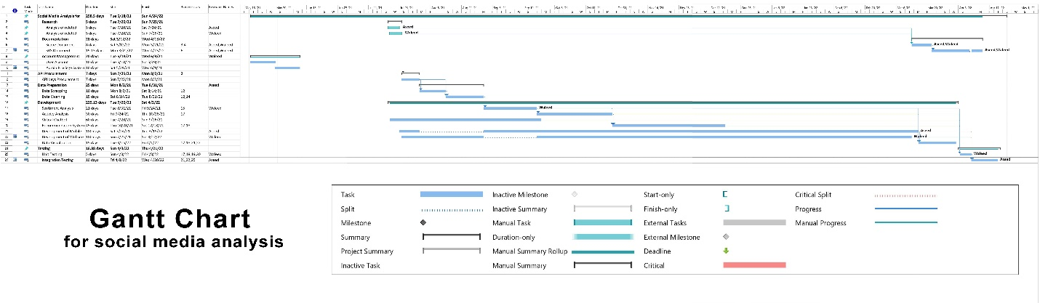

# **Project Staff Organization**

Following are some requirements needed to make a team to make the project successful:

* A total of 6 members needed
* Web designer with minimum of 2 years of experience
* JavaScript developer with React Native knowledge. Min of 3 years of experience needed
* UI/ UX developer with 6 months of experience needed.
* Flutter developer with 2+ years of experience
* Business Analyst
* Data Science experts who have experience in data analysis and machine learning

# **Development Risks and Risk Management Actions**

Following are two common type of risks involved:

* The person applying may have the experience required for the job but lack skills. In order to manage this problem, provide a small task similar to that of the project and analyses their skills.
* There is a high risk of losing money on the project. You may face cost overruns
* There is a risk that the project may not finish on time

# **Milestones**

|  |  |  |  |
| --- | --- | --- | --- |
| **S No** | **Milestone** | **Completion Time** | **Project Products** |
| **1** | SRS | 1 week | Document |
| **2** | UI Design Mockups | 5 days | Prototype |
| **3** | Sentiment Analysis Model | 3.5 weeks | Interface |
| **4** | Software Design Model | 3 days | Document |
| **5** | Integration Testing | - | Document |
| **6** | Project Completed | 3 months | Software |